A Machine Learning Framework for Biometric Authentication Using Electrocardiogram

In this paper author is using machine learning algorithm to authenticate user via Electrocardiogram (ECG) dataset and this authentication can be used to authenticate users in Hospitals, Security Check and Wearable devices. In hospitals then can collect ECG data from patients and assign ID to each ECG record and then train this ID and ECG with machine learning algorithms such as SVM, decision tree, ANN and CNN algorithms. After training model then this trained model can be used to authenticate patient by giving ECG input.

To implement this project we have used ECG dataset from 20 persons and below screen shots showing all 20 person ECG records and each record contains 5000 ECG readings

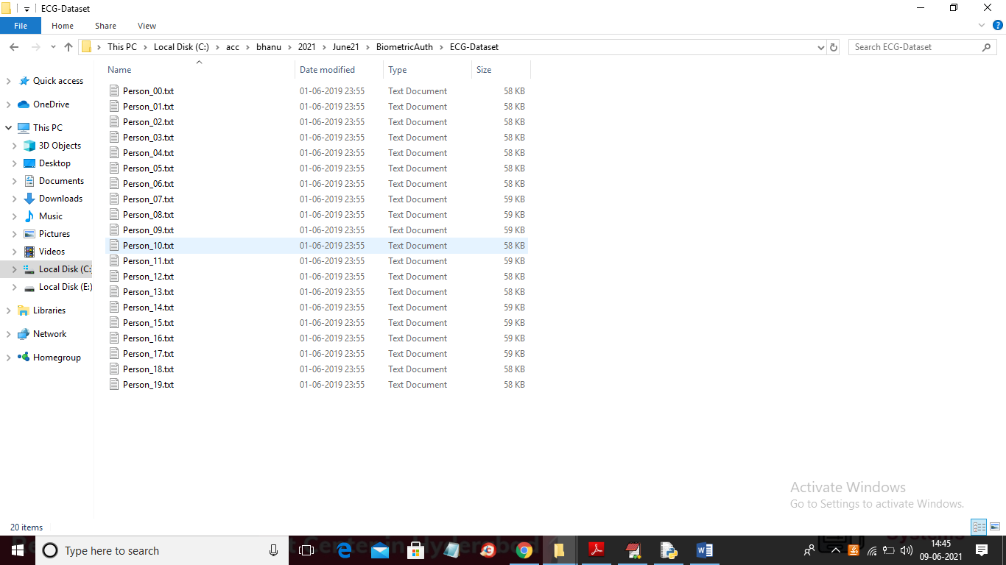

In above screen open any file to see that person ECG data and to implement this project we are developing following modules

1. Upload ECG Dataset: using this module we will upload dataset to application
2. Dataset Preprocessing Fourier & Flipping: using this module we will preprocess dataset to remove missing values and then apply flipping and Fourier transform algorithm to select important attributes from dataset
3. Train SVM Algorithm: using this module we will train SVM with ECG dataset and then calculate accuracy, mean squared error and mean absolute error on test data
4. Train Decision Tree Algorithm: using this module we will train Decision Tree with ECG dataset and then calculate accuracy, mean squared error and mean absolute error on test data
5. Train ANN Algorithm: using this module we will train ANN with ECG dataset and then calculate accuracy, mean squared error and mean absolute error on test data
6. Train CNN Algorithm: using this module we will train CNN with ECG dataset and then calculate accuracy, mean squared error and mean absolute error on test data
7. Upload ECG Test Data & Authenticate User: using this module we will upload test ECG data and then machine learning algorithm will identify user id from that test ECG data
8. All Algorithms Comparison Graph: using this module plot accuracy comparison graph between all algorithms

SCREEN SHOTS

To run project double click on ‘run.bat’ file to get below screen

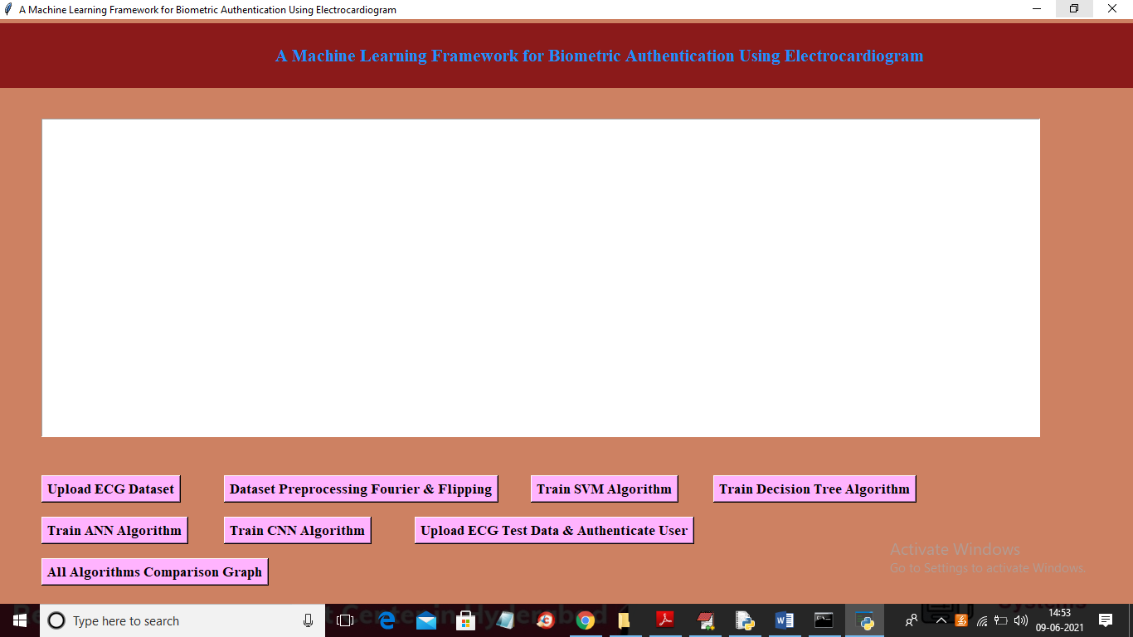

In above screen click on ‘Upload ECG Dataset’ button to upload dataset and to get below screen

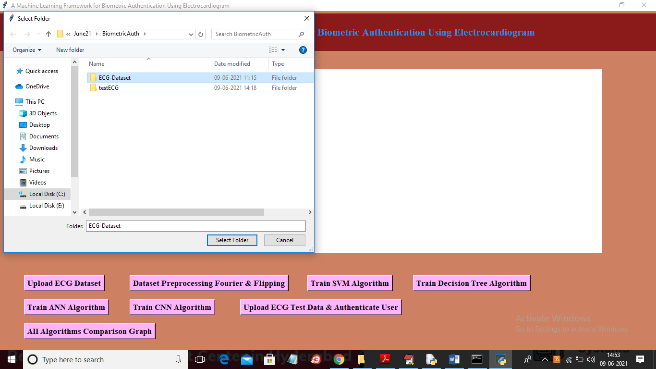

In above screen selecting and uploading ‘ECG-Dataset’ folder and then click on ‘Select Folder’ button to load dataset and to get below screen

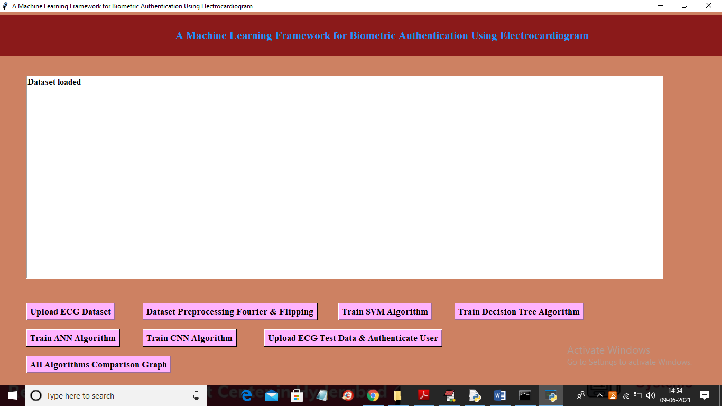

In above screen dataset loaded and now click on ‘Dataset Preprocessing Fourier & Flipping’ button to read and clean dataset

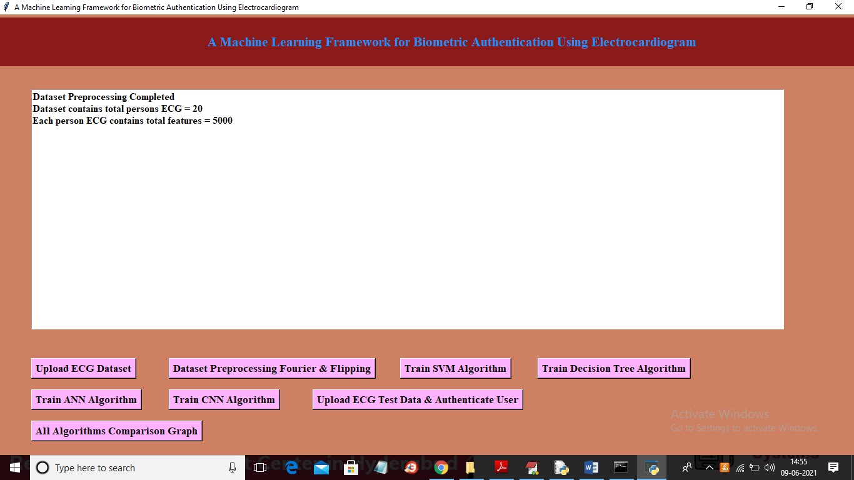

In above screen dataset contains 20 person ECG records and each ECG record contains 5000 values and now click on ‘Train SVM Algorithm’ button to train SVM with above dataset

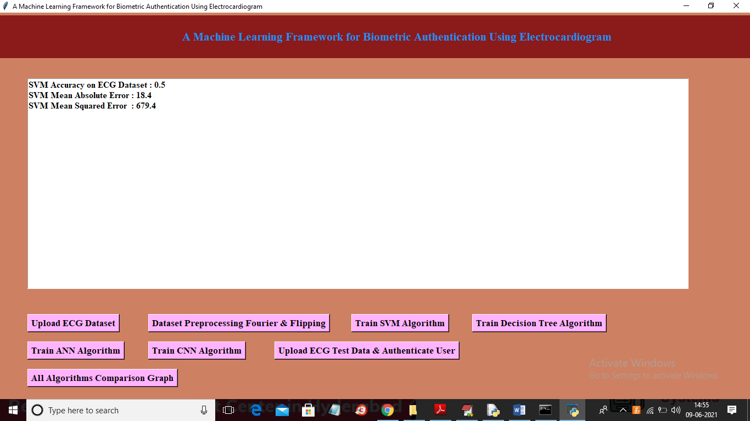

In above screen SVM is trained and we got accuracy as 0.50% and now click on ‘Train Decision Tree Algorithm’ button to get decision tree model

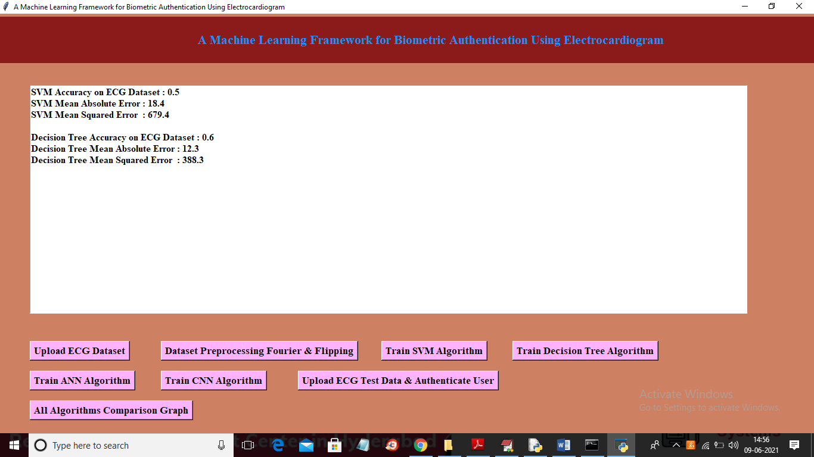

In above screen with decision tree we got 0.60% accuracy and now click on ‘Train ANN Algorithm’ button to train ANN with above dataset

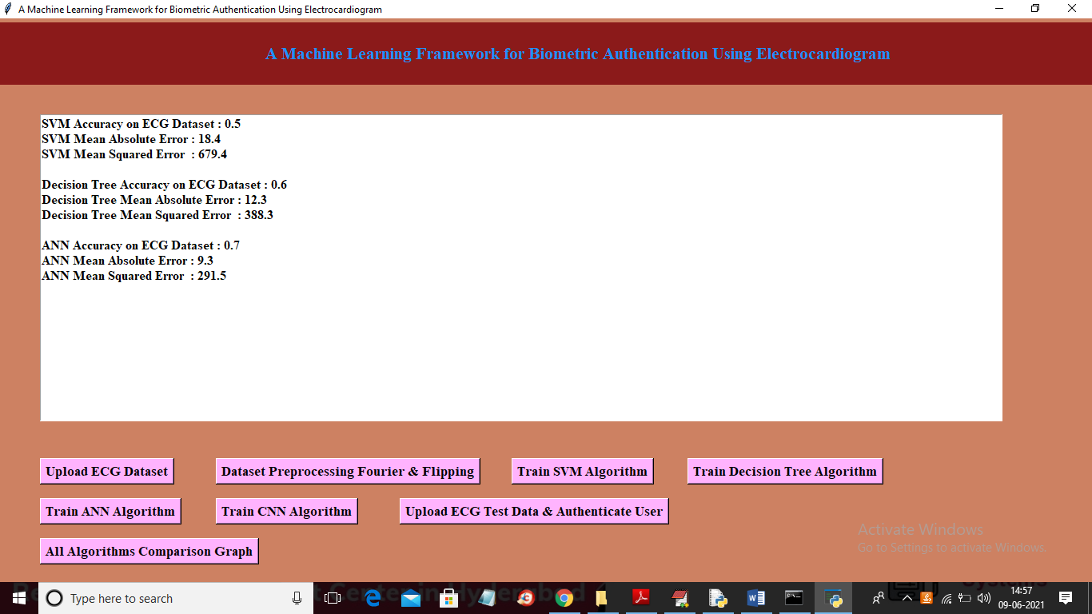

In above screen with ANN we got accuracy as 0.70% and we got MSE and MAE for each algorithm and now click on ‘Train CNN Algorithm’ button to train SVM with above dataset

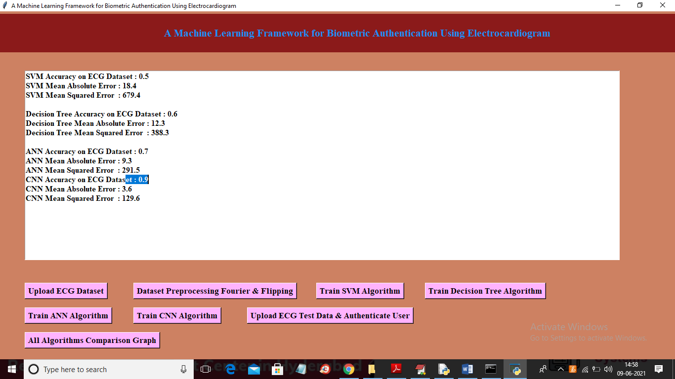

In above screen with CNN we got 0.90% accuracy and now click on ‘Upload ECG Test Data & Authenticate User’ button to upload test ECG and then application identify person ID from test data

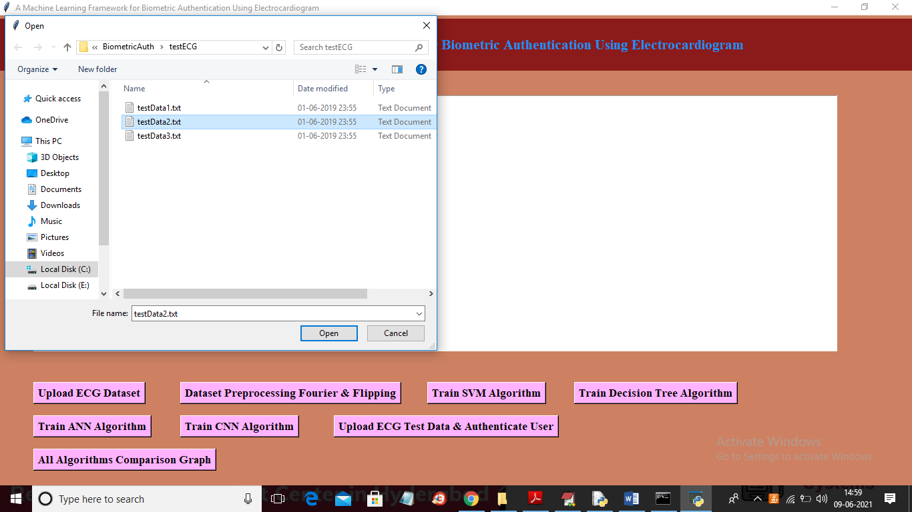

In above screen selecting and uploading ‘testData2.txt’ file and then click on ‘Open’ button to get below authentication result

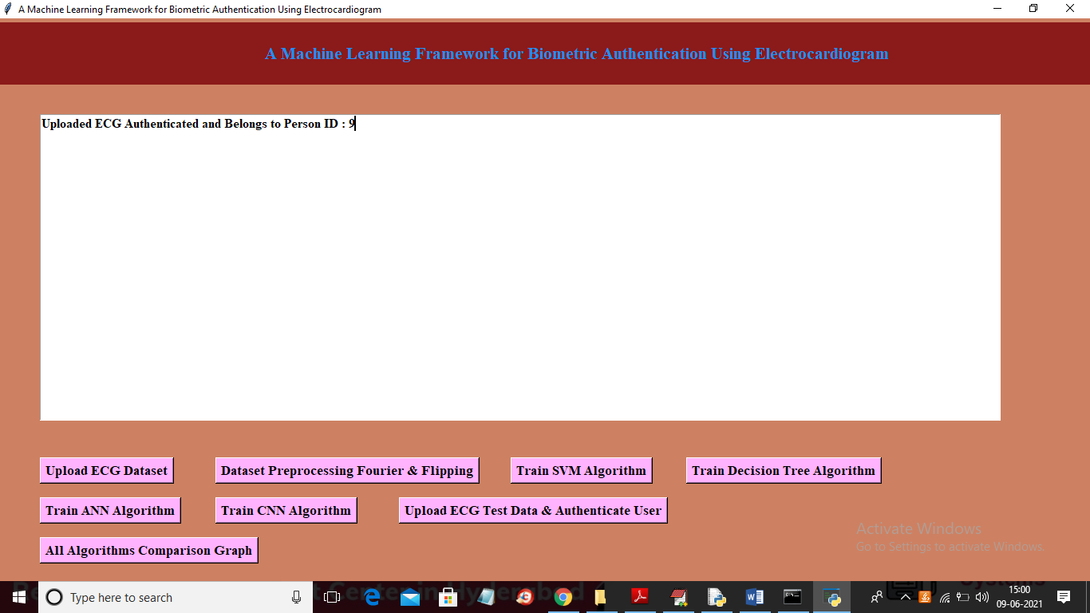

In above screen person ID is Authenticated or Identified as ‘Person ID 9’ and similarly you can upload any other test data and authenticate user. Now click on ‘All Algorithms Comparison Graph’ button to get accuracy graph of all algorithm

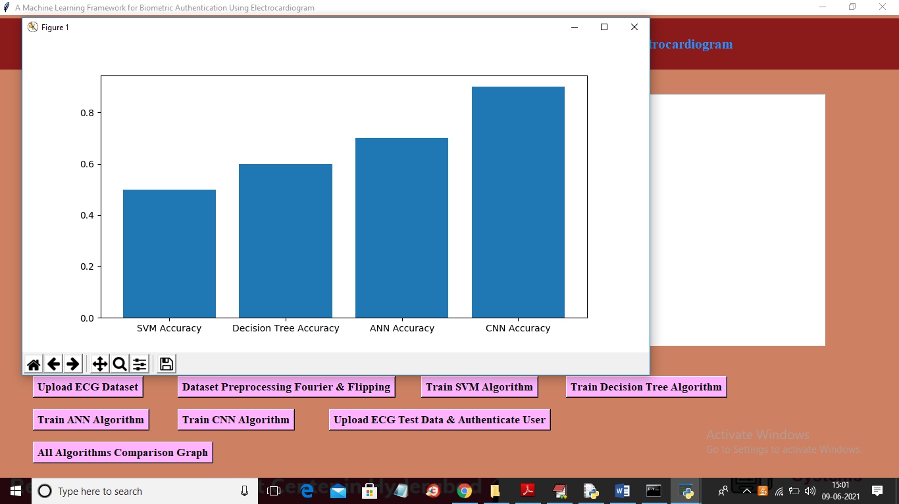

In above graph x-axis represents algorithm name and y-axis represents accuracy of those algorithms and from all algorithms CNN is giving better result